Disclaimer

This document is for planning and input purposes only and does not represent the school’s final budget. The school’s final budget will be approved at the Governing Council Meeting on April 19, 2017 at 5:00 PM.



2017-2018 Budget

SAC Meeting April 12, 2017

# Budget Analysis

## Budget Highlights

Corrales International School (CIS) collaborated with administration, staff and parents to develop a budget that is aligned with the School’s goals. CIS balanced the budget on anticipated revenues for Fiscal Year (FY) 2018 without using cash carryover.

The expected mandated changes used to prepare the budget were as follows:

* State Equalization Guarantee unit value decrease of 2%
* Medical insurance increase of 1.82% - 3.98%
* Risk insurance increase of 2.83%

CIS anticipates having four teachers who will receive a raise due to change in licensure level; two teachers moving from a level II to a level III and two teachers moving from a level I to a level II. The School has one teacher who anticipates completion of their National Board Certification.

Other anticipated changes are a facility rent increase of approximately $21,888.

## Budget Summary

The School’s overall projected budget revenue is $2,967,451 which includes an anticipated increase of SEG in the amount of $63,489 or 2.77% from 2016-2017. All funding at this time is based on estimates from FY17 as final funding has not been released by the Public Education Department (PED) or Albuquerque Public Schools (APS) as of the date of this packet.

Overall, the Operational fund makes up the majority of the school’s budget at 79% of total revenue. The Operational fund is used to cover the costs of operations. The other funds help support the School as follows:

* Instructional Materials fund provides support for classroom material and supplies;
* IDEA-B supports special education costs;
* Title II supports teacher and administrator training and recruitment;
* Lease Assistance helps pay for part of the school’s lease
* SB-9 and HB-33 support lease purchase agreement costs & capital purchases, such as technology.

# 

# Revenue

## Revenue Summary

Below is a chart that summarizes the revenue change for CIS. The budget is expected to increase by about 1.86% when considering projections for federal Flowthrough funds and other funds listed below. This increase is due to the anticipated increase in SEG.

The Perkins Grant, CSI, Dual Instructional Materials, SB-9 State Match and Lease Assistance awards are presented below for informational purposes and are projected to be similar to what was received in the 2016-2017 school year. These funds are not being included in the initial budget and will be budgeted using budget adjustment requests once initial 2017-2018 awards have been issued.

# Expenditures

The school balanced its budget without using cash carryover due to the anticipated increase in SEG funding. The school is accumulating the fund balance in SB-9 and HB-33 to use towards the down payment on a permanent building. Below is further information on the Operational (Fund 11000) portion of the budget.

## Expenditures by Function Code

The data indicates that the school has budgeted 63% of operational expenditures in the classroom and 9% in support for total of 72% for instruction and support.

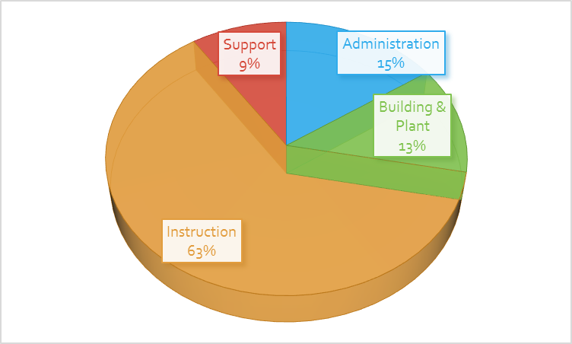

*Please note – the lease cost is not entirely budgeted until lease assistance allocations are released around September of the next school year in which a BAR will be submitted for governing council approval. The projected portion covered by the operational fund is included above.

## Expenditures by Object Code

The majority of the operational budget, 71%, goes towards compensation and benefits followed by 14% going towards property costs. Below is a chart that illustrates the breakout by object code.

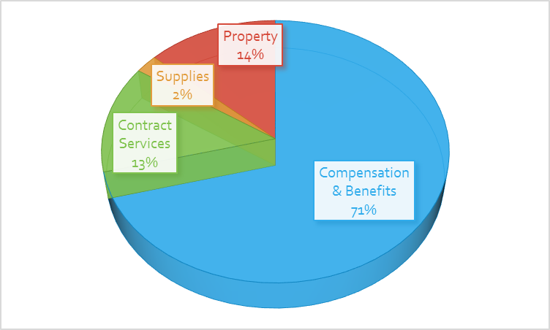

**Personnel Costs**

Below are two charts that identify the budgeted positions and additional compensation (stipend) costs. Overall, the budget includes a total FTE of 27.55, which is the same as the FTE for FY17.



Stipends:



**Non-Personnel Costs**

Listed below are non-personnel costs that are considered significant re-occurring costs that are included in the budget.



**One-Time Contracts**

Below are one-time contracts or expenditures that are included in budget.



## 

## Other Costs

Below are other expenditures that are included in the budget.

