Newsletter 12/1/2017
* Friday December 15th will be a Half-day for CIS. All Students will be released at 12:30.
*Yearbooks will be on sale Dec 1- 31 for $25, and on Jan 1 until Apr 8 (last day to order) the price will be $28.
This is the link to order (Ctrl + click if just clicking doesn’t work): https://link.entourageyearbooks.com/view_account.asp?l=857E484E-ACA8-4906-80D6-ED31C4EC1B46
Parents that would like to submit ads can pay via the PTA box and email Lisa Tiger (tigerl@corralesis.org) their ad. I'll have order forms for year in the lobby they can pay via check or cash.
*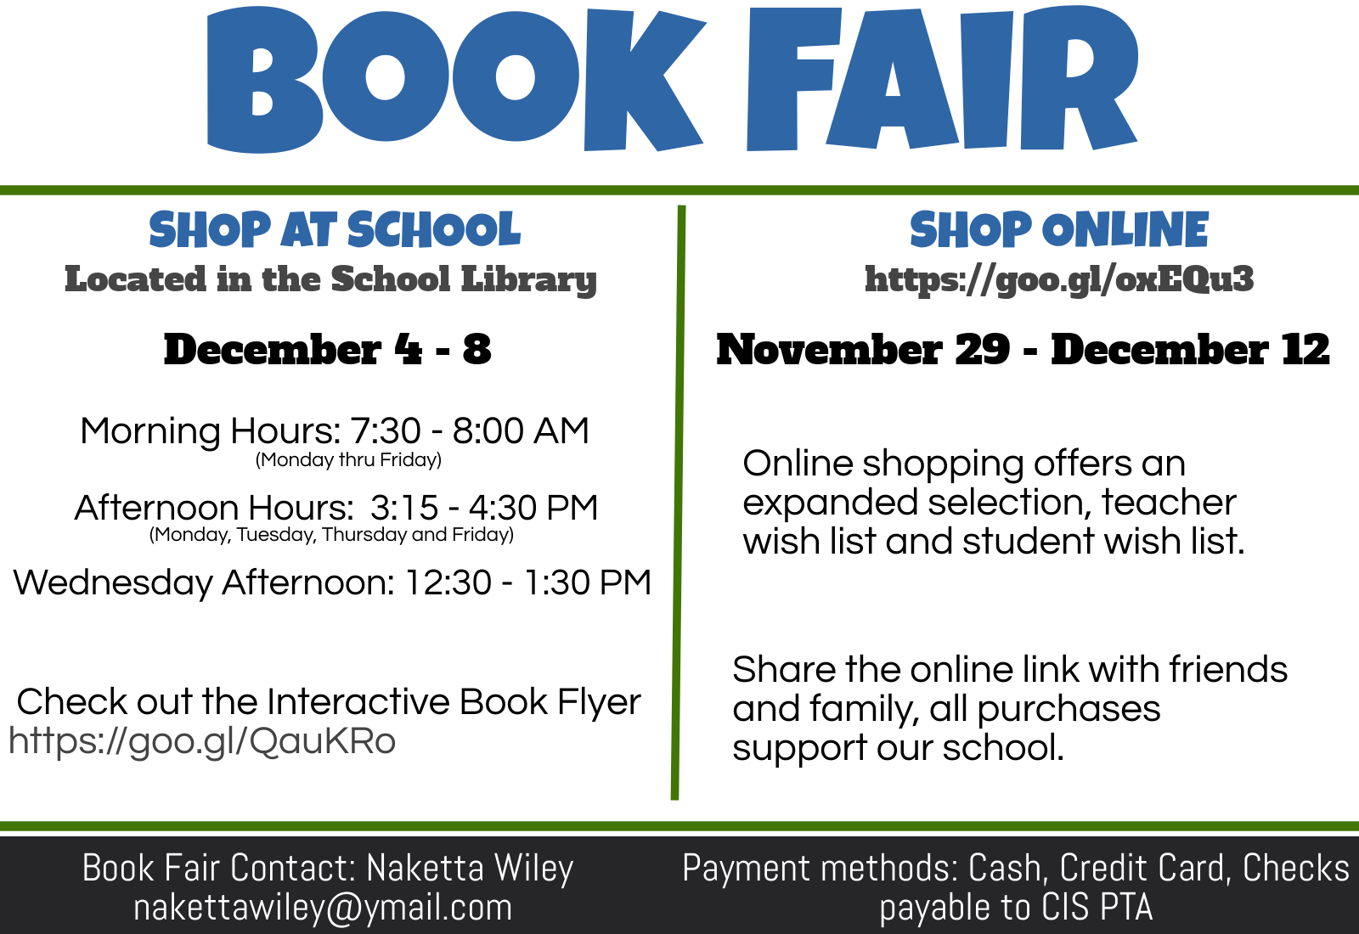
*PTA will selling snacks before and after school next week, Monday through Thursday.

* Come & Shop at our Annual Shop & Stroll Cocoa Jam on December 8th After School till 5pm.

There will be Shopping, Food for sale. Games, Music & tons of fun! Shop & Stroll is a fun way for our students to buy inexpensive gifts for their loved ones.

We are still accepting Donations of any item a child would find fun to give a loved one as a present. Shop & Stroll Donations can be placed in the bin in the Lobby from now tell December 7th

Thank you.

PTA will be selling Hot Cocoa Grams. Students will be able to Send A Warm Holiday wishes with a Hot Cocoa Grams to a friend For $1.00 per Gram. Grams will be sold Monday December 4th-December13th.

Holiday Gift Raffle Tickets are $2.00 per ticket.
1st Prize is a 4 quart crockpot.
2nd Prize is a Handmade Holiday Wreath
3rd Prize is a Hand decorated and lit reclaimed wine bottle.

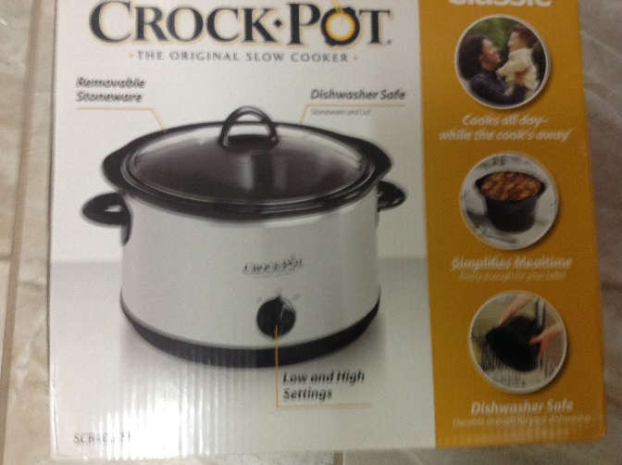  1st prize a 4 quart Crock pot 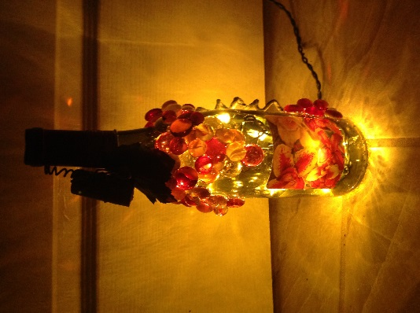 | 2nd Prize a Handmade  Door Wreath  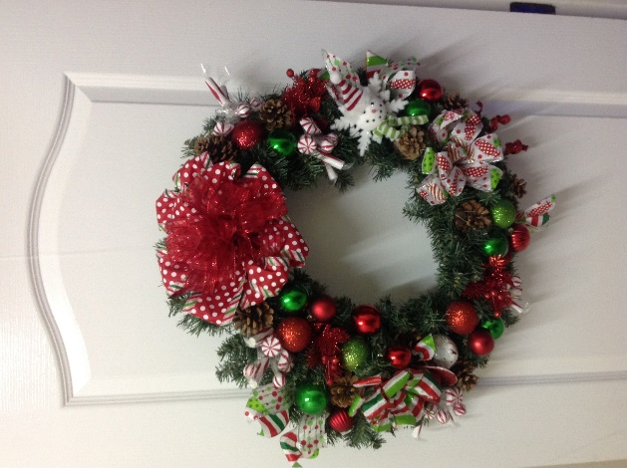
3rd Prize a Hand Decorated lit reclaimed wine bottle

