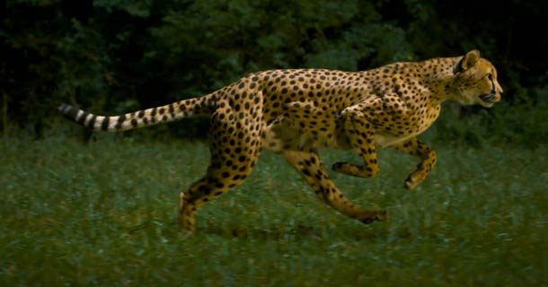Slow Moving Cheetah

TODAY’S NEWS
Curriculum Update

Unit I - Physics of the Universe

Key Concept
Systems are sets of interacting or interdependent components. Systems provide structure and order in human, natural and built environments. Systems can be static or dynamic, simple or complex.

Global Context
Scientific and Technical Innovation Students will explore the natural world and its laws; the interaction between people and the natural world; how humans use their scientific and technological advances on communities and environments; the impact of environments on human activity; how humans adapt environments to their needs.

Motion
After reviewing variables, scientific notation, significant figures, the metric system and dimensional analysis, I am thrilled to start Unit I. Students are currently learning about motion and how to distinguish between distance, displacement, speed, average and instantaneous velocity, and acceleration. They have completed related problem sets, an activity “speed and the two step,” and are learning how to read distance and time graphs. We will conclude this unit studying free fall, motion in two dimensions, vectors, and projectile motion. Please have students check “Google Classroom” for the most current schedule of assignments, activities, labs, and assessments. Please check Power School for recent grades.

