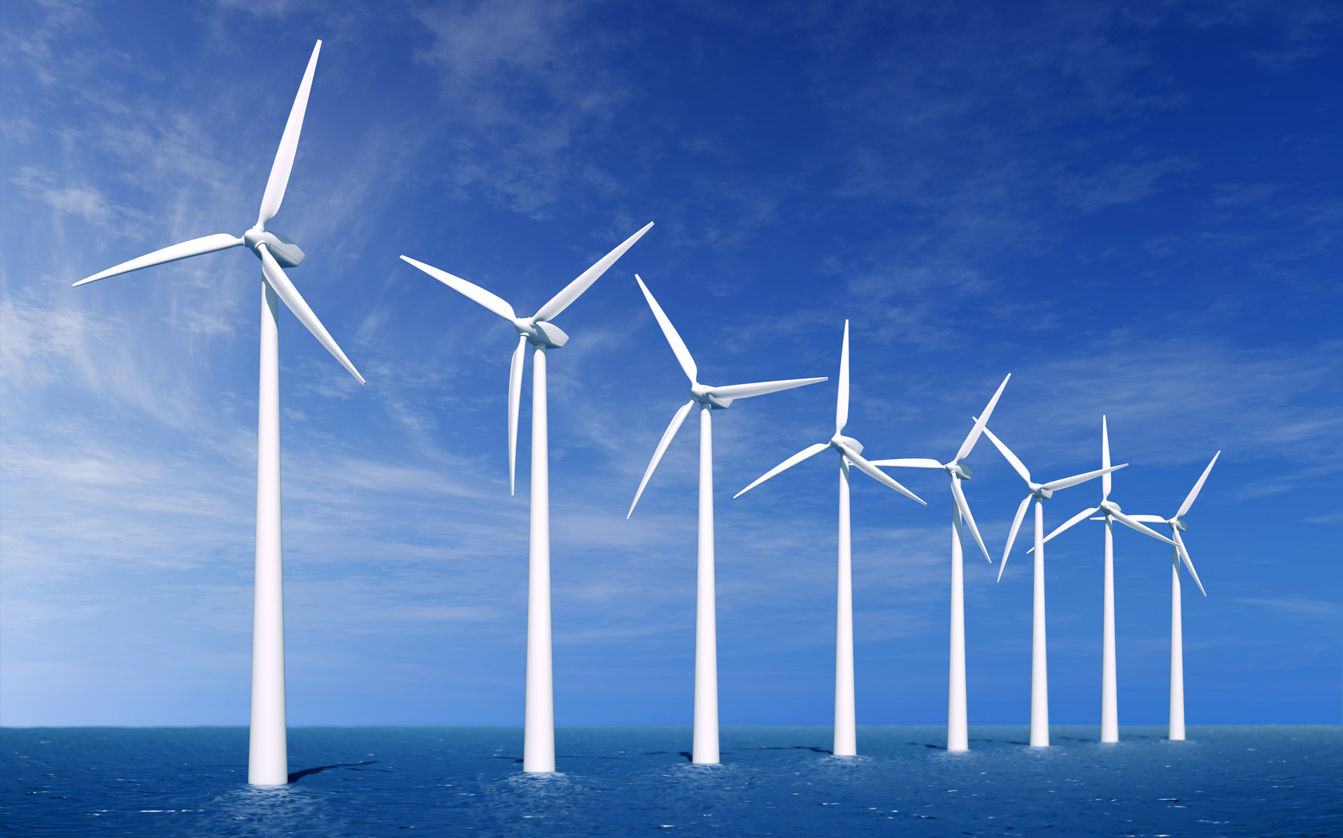

Alternative Energy Project

Today we commonly use electrical energy to power our homes, schools, and businesses. In order to produce electrical energy we often harm communities and the environment all while attempting to improve the quality of life for humans. But is there a better way? Is there a cleaner solution to our energy needs? In trying to avoid environmental issues, scientists are developing new sources of energy that are safer, cleaner, and cause less harm to the environment and surrounding communities. These sources are called alternative energy resources.
For this project you will choose a partner and one of the following types of alternative energy sources to research:
- Solar Energy
- Geothermal Energy
- Tidal Energy
- Wind Energy
- Biomass / Biogas Energy
- Biofuels
- Fuel Cells
- Other approved alternative energy source
Requirements:
You must research and answer the following questions in your own words using correct grammar and punctuation.
- Describe the alternative energy source.
- Where is that energy produced?
- How is that energy produced?
- What are the advantages and disadvantages of this type of energy?
- In your own words, explain why it is beneficial to use this type of energy.
You are acting as an energy advertising agency. Your task is to successfully advertise an alternative energy. You may create a digital poster, website, video/commercial, or other online resources like animatron. The final product must include the energy company’s name, a hand-drawn or digitally created company logo, a slogan (motto, catch-phrase, etc.), and at least one picture advertising the energy source. You must also include the typed answers to the above research questions either in the final product or on a separate piece of paper. Remember you are trying to convince people to consume/support alternative forms of energy. Be creative and persuasive!!

Below are some online resources to help you get started.

AE KIDS | EIA ENERGY KIDS | ENERGY AND KIDS
RENEWABLE ENERGY | ALTERNATIVE ENERGY

