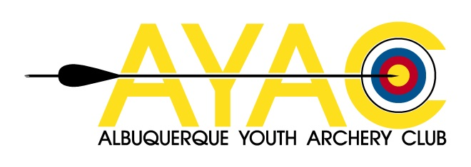
PARTICIPANT ACKNOWLEDGEMENT AND RELEASE

In the event of a medical emergency, I hereby give consent for the Albuquerque Youth Archery Club to provide or seek medical attention, transportation, and emergency medical services as warranted by the circumstances.

I acknowledge receipt of the shooting range rules, and agree to abide by these rules. I understand that any violation may result in my immediate expulsion from these activities. I, the undersigned, do hereby release Albuquerque Youth Archery Club and Corrales International School and all personnel, from losses, damages, or personal injuries incurred by myself while participating and/or viewing an archery event. I fully understand and acknowledge that archery, as other outdoor activities, involves certain inherent risks, and I attend and/or participate in this activity with full knowledge of those risks.

I HAVE READ THIS RELEASE. I UNDERSTAND THAT IT AFFECTS LEGAL RIGHTS AND RESPONSIBILITIES AND I HEREBY AGREE TO ITS TERMS AND CONDITIONS. I HEREBY CONSENT AND AGREE TO THE TERMS OF THIS RELEASE, AND HEREBY WAIVE ANY CLAIMS AS DESCRIBED HEREIN.

PARENT/GUARDIAN
PRINT NAME SIGNATURE DATE

PARTICIPANT/STUDENT
PRINT NAME SIGNATURE DATE

