Corrales International School Newsletter

UpEvents

Upcoming Events

March 12-
MYP Report Cards
March 13-
CIS Foundation 3:30 pm
SAC Committee 5:00 pm
March 14-
No after School clubs (staff safety training)
Spring Pictures
March 26th – April 2
Spring Break!

March 8, 2018
Thank you to all parents, students, and staff for a great International Day! A special thanks to Mrs. Samaniego-Crump, Mrs. Norma Giannini and all their students for the fantastic art work displayed all through the school!
Also, thank you to Albuquerque City Councilman Pat Davis and members of the Albuquerque Police Department for taking the time to discuss community issues with Mrs. Tigers Government/Economics classes.

Dear Parents,
As a parent at CIS I am so grateful that our kids are getting an amazing education at this International Baccalaureate school. We are so fortunate to have our kids in this safe environment with other kids and parents who truly care.
We are asking for all parents to please sell at least 2 car wash tickets. This will help the CIS foundation immensely! The school gets 1/2 the proceeds from every ticket sale.
Please do your part to help the school raise this much needed money! We are so fortunate that our kids are here and we want to support our school any way we can!
Thank you for your help!
Please just sell 2 tickets!!
Jennifer Tobin
CIS parent

Yearbooks
Global Perspective is our theme this year! Don’t miss out on all the memories being at CIS this year! Purchase your yearbook online www.entourageyearbooks.com or order forms will be in the lobby starting Tuesday January 16. Also if you would like to order a dedication page please submit payment to the PTA box (checks should be made out to CIS PTA) and email your dedication and pictures directly to Mrs. Lisa Tiger tigerl@corralesis.org subject line should read “ Yearbook dedication with your students name)
Prices:
Yearbook 28.00
Full page 8.5X 11 inches $80
Half page 8.5X5.5 inches $50
Quarter page 4.25X5.5 inches $ 20
Eighth of a page 4.25X2.75 inches $10

CIS Foundation
The Foundation's next meeting is Tuesday, March 13th at 3:30 at the school. See you there. We are seeking new board members. Three of us have fulfilled our terms.
The foundation has sent home car wash ticket sales forms. Please send money or checks payable to CIS Foundation. 7th and 8th grade will receive their forms tomorrow. Tickets are $12 each. The tickets will be sold through March 22nd. The proceeds will go towards a new building.

CIS PTA
Can you believe the end of the year is upon us! This year has zipped by so fast. It's crazy to think we still have so much to complete before we can head into the summer!
We have spring pictures March 14. This will be class pictures, sibling, and any make up photos because student was absent or not part of the CIS community in the fall.

Athletics
CIS Soccer Schedule:
DATE |  | TIME |  | HOME |  | VISITOR |  | LOCATION
Mar 7 Wednesday |  | 4:30 |  | CIS |  | ECRA |  | BHP 8
Mar 16 Friday |  | 5:00 |  | CIS |  | AIMS |  | BHP 8
Mar 21 Wednesday |  | 5:00 |  | SVP |  | CIS |  | BHP 8
Apr 2 Monday |  | 5:30 |  | CIS |  | SVA |  | SVA
Apr 11 Wednesday |  | 5:00 |  | CIS |  | TIS |  | BHP 8
Apr 23 Monday |  | 5:00 |  | CA |  | CIS |  | BHP 8
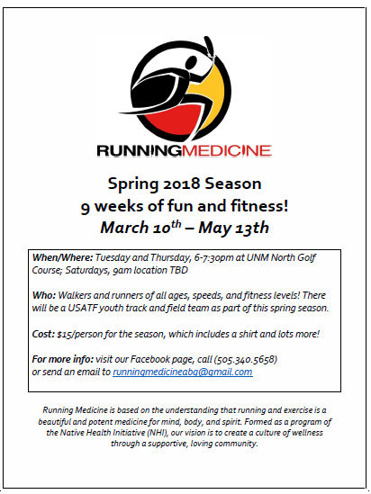
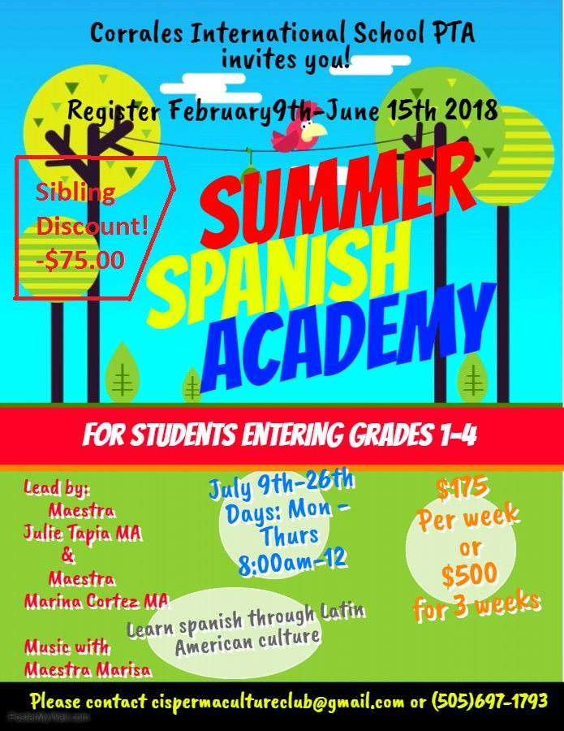
Robotics
Robotics club on Wednesday afternoons. Build and program robots. Coming soon: CIS Underwater Robot!
Meeting on Wednesdays from 1230-200 pm, 2/21/18 until the competition, 5/10/18.

Players
A player is any member that competes in challenges. Players can be any age but are divided into four divisions:
Elementary School | ~ 8 to 10 years
Middle School | ~ 11 to 13 years
High School | ~ 14 to 18 years
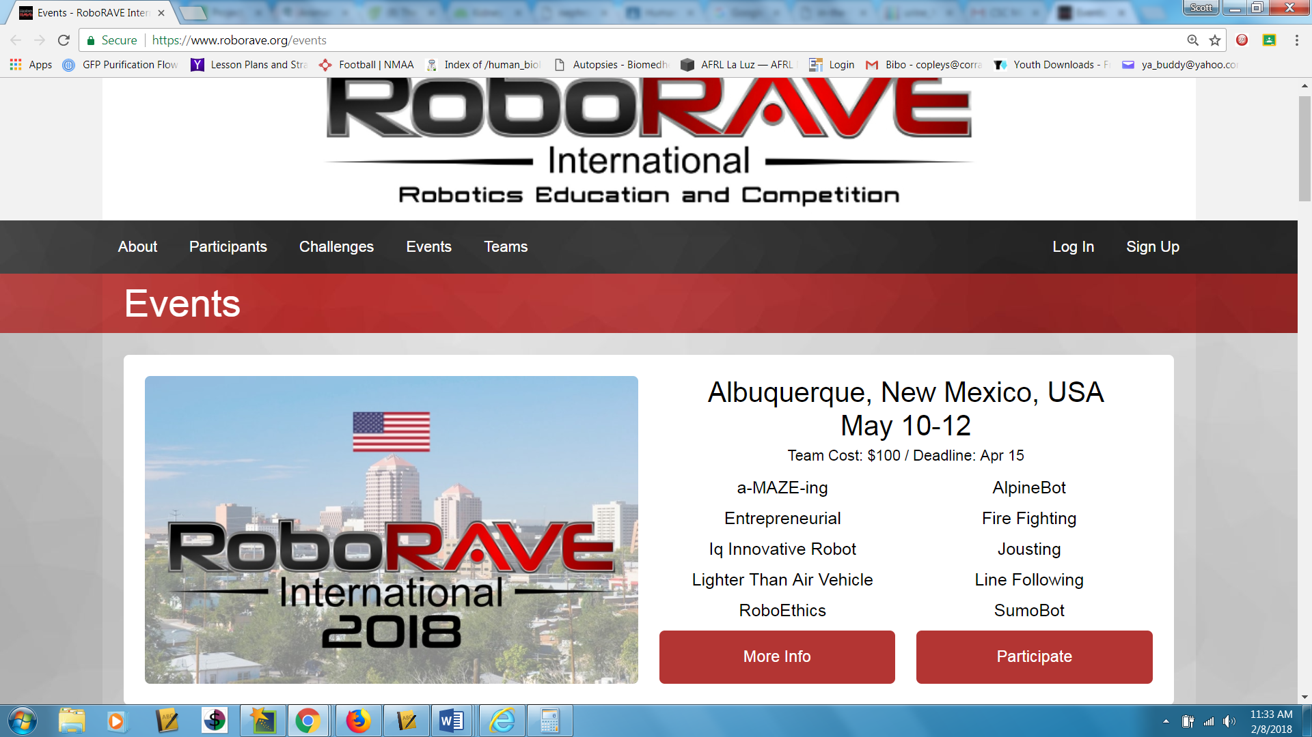
We are looking for you to join us and compete for the CIS team.
Email questions and interest to copleys@corralesis.org

