Corrales International School Newsletter
9/13/2019

Parents:

*CIS Picture day will be Tuesday September 24th. Students may wear their own clothes but they must still be school appropriate.

*Campus Specialties will be at CIS to meet with our Seniors on September 26 at 9:30.

*The Corrales International Homecoming Social for all MYP (Mid-Year Program, grade 7-12) will be September 15th from 1:30 to 4:00 pm in the MPR (multi-purpose room).

*Flu shots for students and families will be available at CIS on October 4th. More information will be coming soon.

*The CIS balloon launch will be October 4th @ 6:30 am.

*Fall break is October 10th and 11th. There will be no school that Thursday and Friday.

*Student led conferences will be on October 31st and November 1st. There will be no school those days, just parent conferences.

*Please look below, in the CIS Foundation section, for information about our Family Dance fundraiser.

Club: 2:30-4:30 (Meets in PTLW Room)
Flag Football: 6th-8th grades from 4:00-6:00 pm (Contact Kim Romero, Sports Director for further
Tuesday August 20th
Archery: 1st-3rd grade from 2:30-3:30 pm in the MPR
Wednesday August 21st
Half Day: Release at 1:30
Permaculture: Movie Day
Flag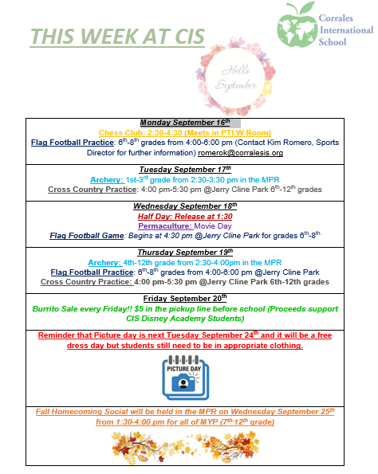 Football: 6th-8th grades from 4:00-6:00 pm (Contact Kim Romero, Sports

CIS Foundation
Our foundation is the group that helps the school by raising money for our Capital needs. (building)
The CIS Foundation is hosting a city wide Family Dance on Saturday November 2nd at the JCC!
This is taking the place of the Father Daughter Dance that they hosted a few years ago and is open to all families who want to dance!
We are looking for help! Looking for graphics creation, flyer printing, advertising help, floral (corsages and pins), photographer, face painting, lighting, decor, DJ and more.
If you have time and would like to volunteer and or can help with getting items, positions donated or anything else we would be so happy!
We can bring in our own food and beverage so even if you just want to sign up to bring brownies or veggie platter that would be appreciated.
Please contact caseyhiester@mac.com to be a part of the dance team!

We need new members! If you want to really help CIS, please consider joining the CIS Foundation.
The next Foundation Meeting is Tuesday 9/24 at 5:30 pm.

