CIS MISSION

The mission of Corrales International School is to achieve, within the framework of the International Baccalaureate curriculum, excellence in bilingual education; to promote international understanding; and live and model its core values of respect, responsibility, connection with nature, and the joy of learning.

GOVERNING COUNCIL MISSION

The mission of the Corrales International School’s Governing Council is to be
a unified leadership team that ensures student success and the fiscal viability
of the school, and hires, evaluates and supports the head administrator in fulfilling the mission of the school and
maintaining the integrity of its charter.

ESSENTIAL
G.C. ROLES

- Ensure that the children of CIS have a positive, enriching, and academically stimulating experience
- Guide through governance
- Support the director’s management role
- Ensure alignment of policy, resources, and infrastructure
- Model excellent leadership
- Engage and represent our school community
- Measure and celebrate achievement

G.C. FUNCTION

- Hire and evaluate the head administrator
- Oversee the school's financial management
- Adopt policy
- Set strategic direction for the school

G.C.’s CORE,
DRIVING VALUES

Increasing student achievement

G.C. MOTTO:

Si se puede!

Corrales International School
5500 Wilshire Ave. NE,
Albuquerque NM 87113
(505) 344-9733
www.corralesis.org

Corrales International School
Governing Council Regular Meeting
5500 Wilshire Ave. NE
Albuquerque, NM 87113
October 12, 2020 – 5:00 p.m.

1. Call to Order

2. Roll Call

3. Adoption of agenda October 12, 2020 meeting.

4. Approval of minutes for the August 10, 2020 meeting.
Approval of minutes for the September 14, meeting.

5. Public Comment: This is an opportunity for members of the public to address the Governing Council ("GC") for up to 5 minutes with comments or issues, whether or not they are posted on the agenda. The Chair may reduce the time for each participant to speak to ensure adequate time to conduct GC business. The GC, by law, cannot take action or have any discussion or deliberation on any presentation made to it concerning an item not listed on the agenda. Any item presented may be noticed on a future agenda for deliberation or action.

6.
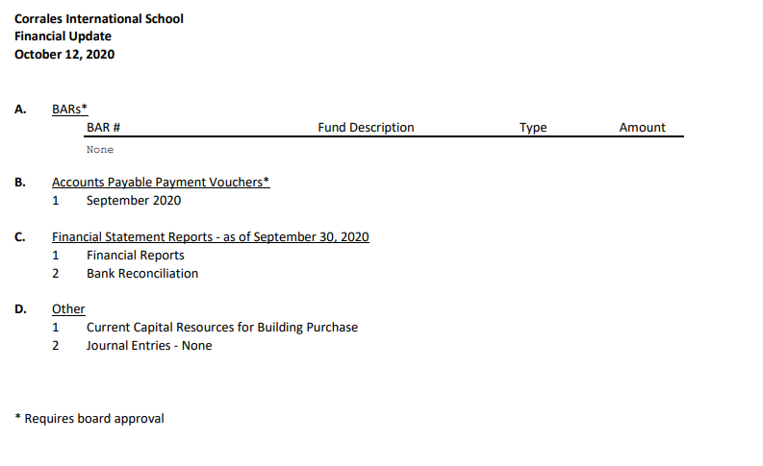

7. GC Business

- Development/Consulting Agreement with DePonte Investments Inc.
- Corrales International re-entry plan for 2020-2021. (Update)
- Training

8. Head of School update

A. Updates
9. Other Business/ GC Member Comment: This is an opportunity for any GC member to make a comment.

10. Adjournment

The next regular meeting of the Governing Council will be on November 9, 2020 at 5:00pm and will take place at 5500 Wilshire Ave. NE, Albuquerque, NM 87113.

“If you are an individual with a disability who is in need of a reader, amplifier, qualified sign language interpreter, or any other form of auxiliary aid or service to attend or participate in the hearing or meeting, please contact the CIS Head of School at 505-344-9733 at least one week prior to the meeting or as soon as possible. Public documents, including the agenda and minutes, can be provided in various accessible formats. Please contact the CIS Head of School at 505-344-9733 if a summary or other type of accessible format is needed.”

