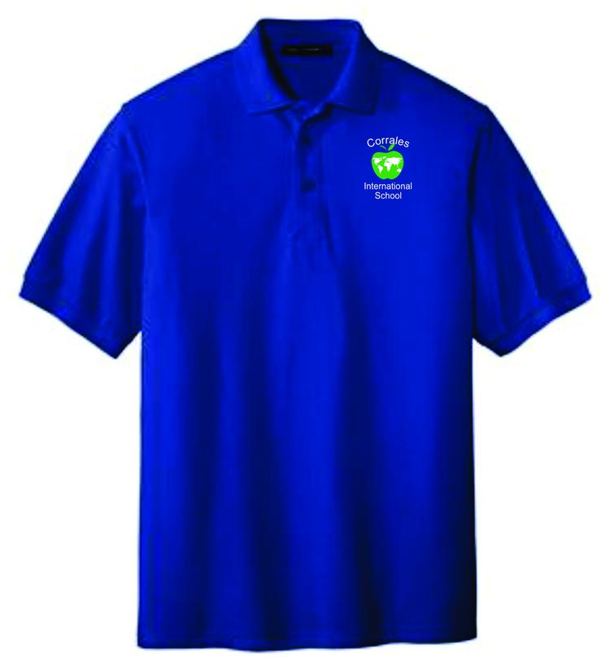
Firedawg Shirts & Embroidery
PYP
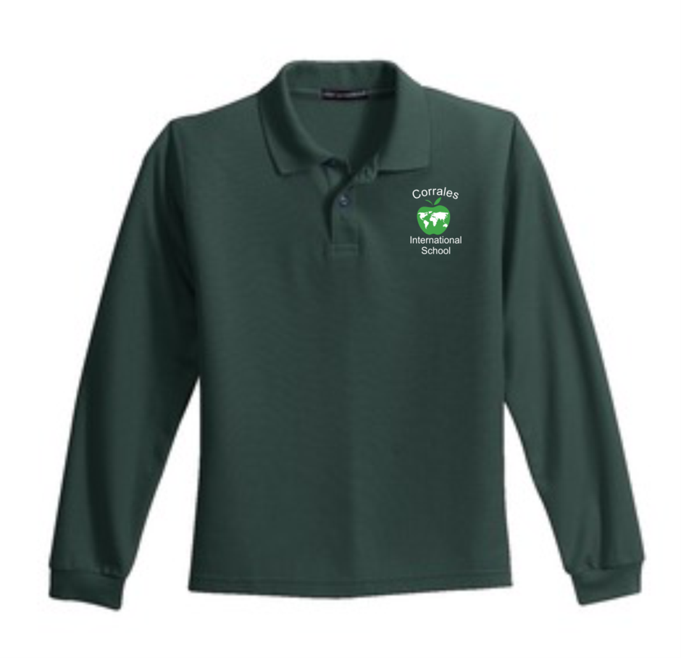
Youth short Youth Long Slv Polo
Slv Polo $19.50
$17.50 Available In Royal,
Available in White & Green
Royal, White, Size XS-XL
Green, Light
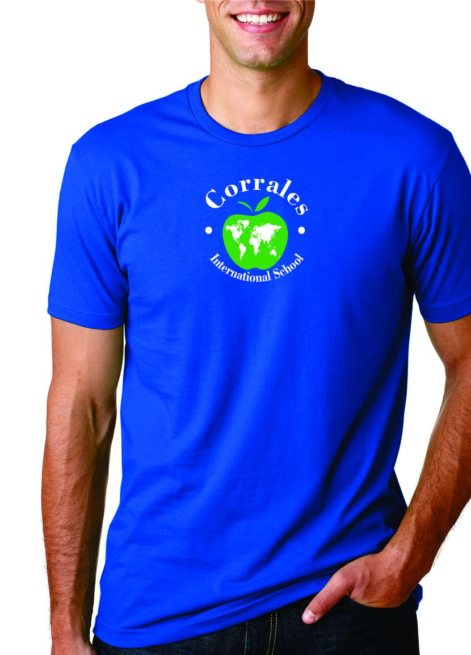
Blue Size
XS-XL
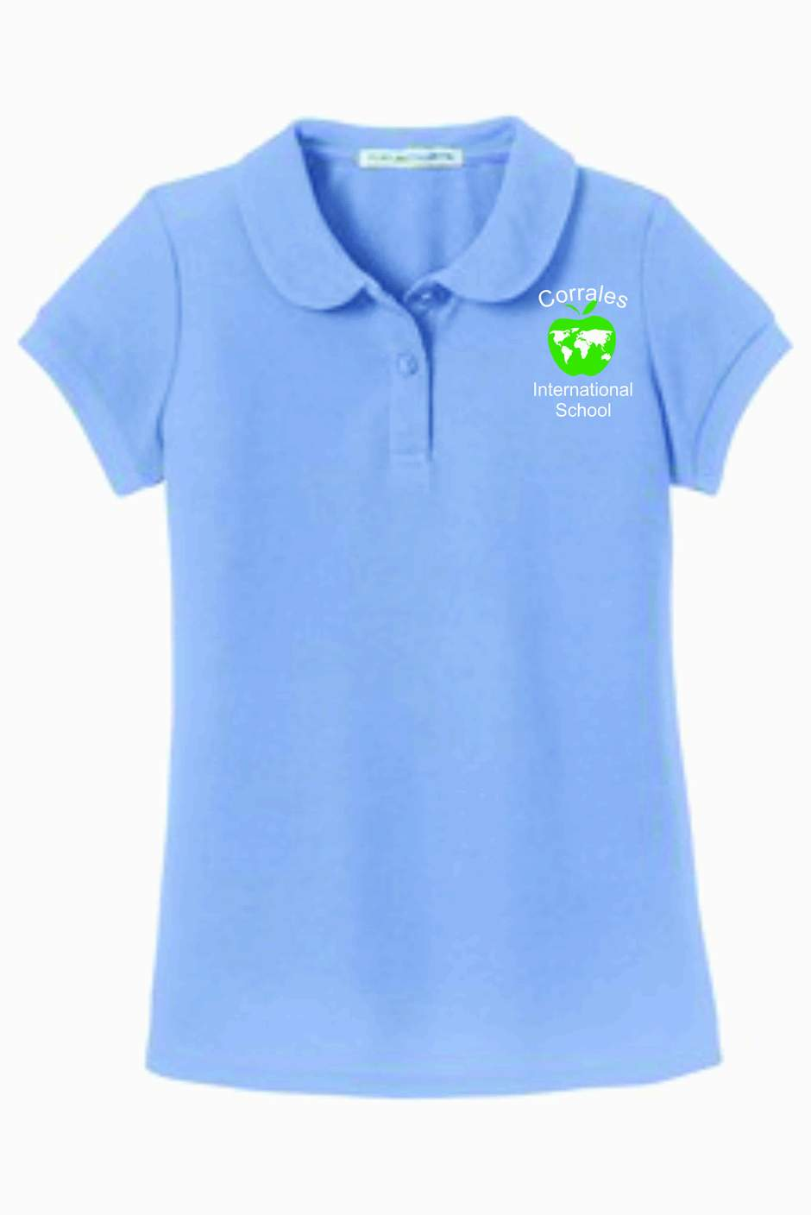
Princess Cut Polo Youth Spirit
$17.50 Shirt $9.00 16.50.
Available In Available in
Royal, White & Royal & Gray
Light Blue
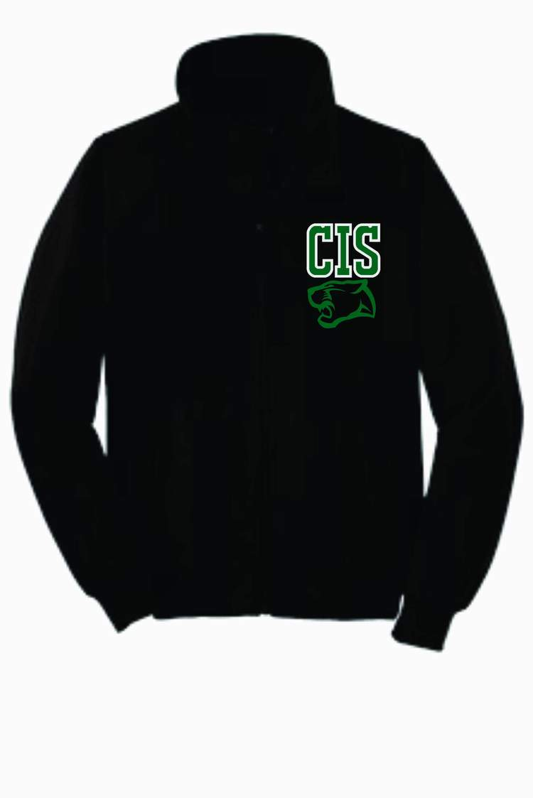
Sizes XS-XL
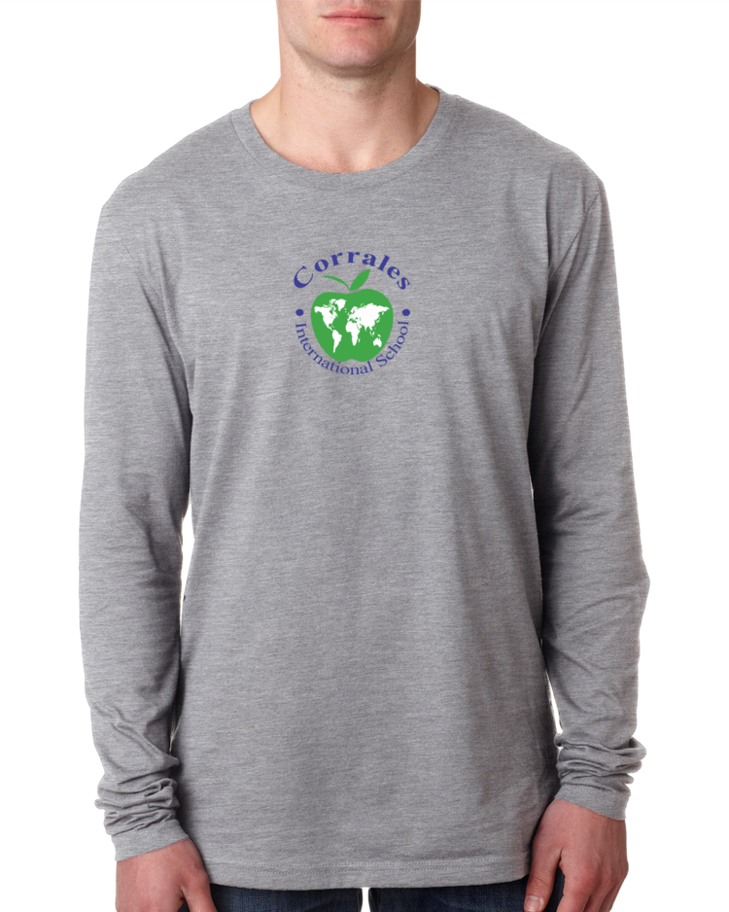
.

Youth
Long
Slv Spirit. Fleece Jacket
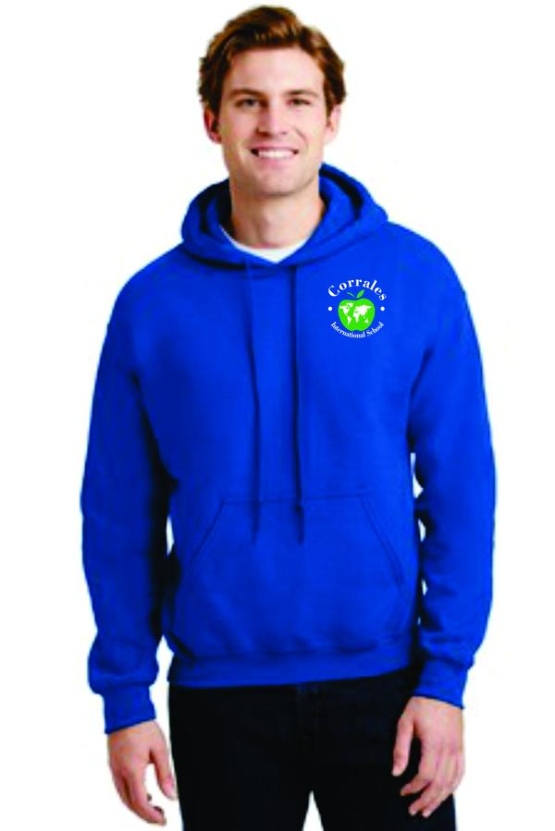
Shirt $13.00 $30.00
Available in Size Sm-XL
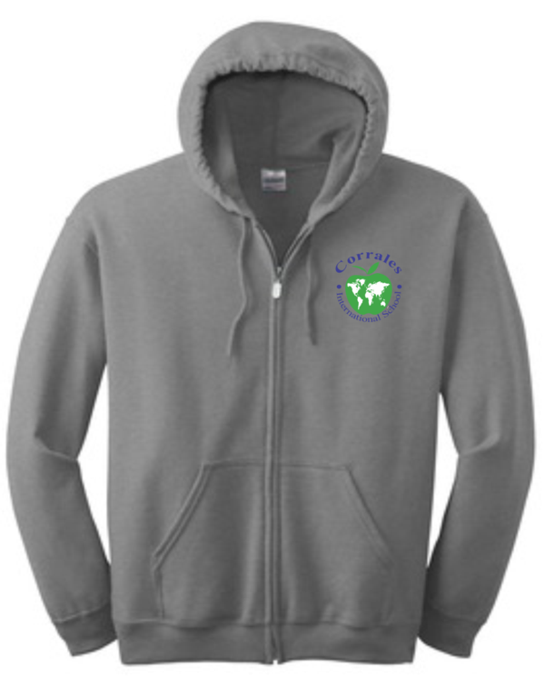
Royal, Gray Add a Name for
Size XSM-XL $3.00 more
.
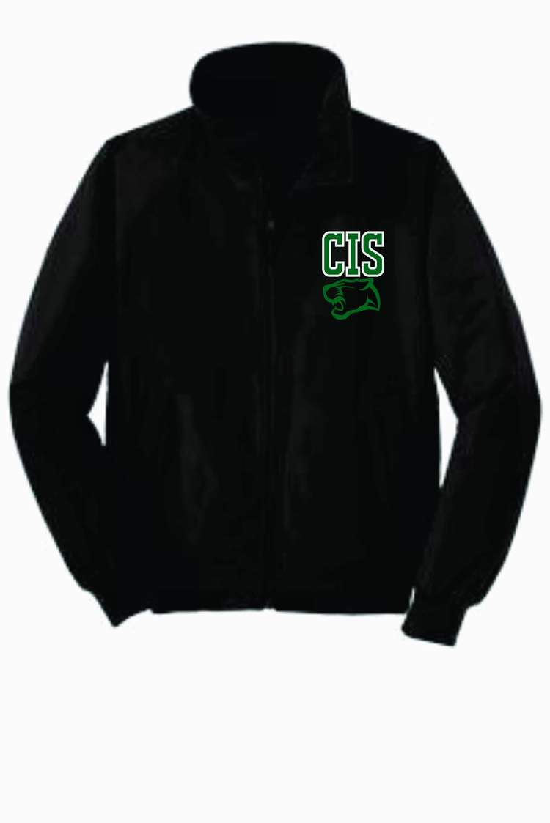

Zip-Up Hoodie.
Or Pull-Over Hoodie Charger Jacket
$23.00 $37.00
Available In Sizes XS-XL
Royal, Gray Add a name for
Sizes XS-XL $3.00 more.
Add a names
for $3.00 more

Adult & Ladies sizes are also available.
To order please go to www.firedawgshirts.com please double check sizes and refer to size charts. As All Sales are Final! No refunds. No Exchanges. No Credit will be given.
No excuses. Tax will be added at time of order. Like us on Face book for special offers and reminders Thank You.
If you have any questions please call 505-750-1672 or Tara 505-681-8694
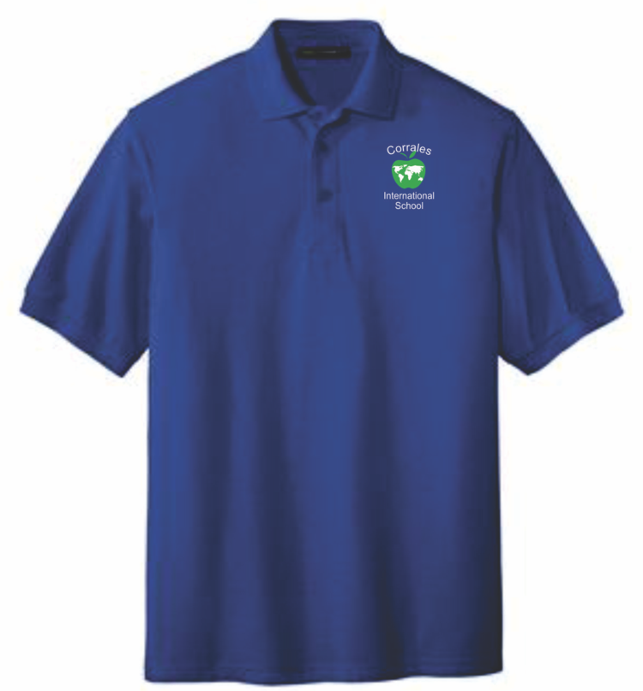
Firedawg Shirts & Embroider
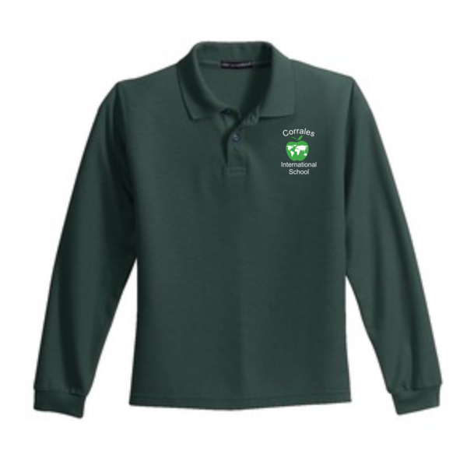
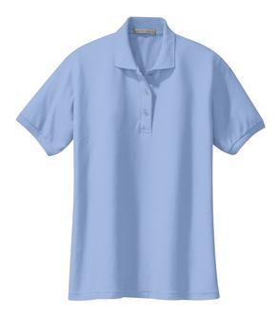
MYP

Adult Shot. Adult Long. Ladies Short
SlvPolo. Slv Polo. Slv Polo
$17.50 $20.00 $17.50
Available in. Available in. Available in
Royal, White, Royal, White &. Royal, White,
Green, Light Blue. Green. Light Blue & Green

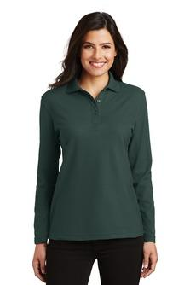

Ladies Long. Adult Spirit Short Ladies Cut Spirit
Slv Polo. Slv Shirt $9.00 Short Slv Shirt $9.00
$20.00 Available In. (This cut is fitted & runs a bit sm)
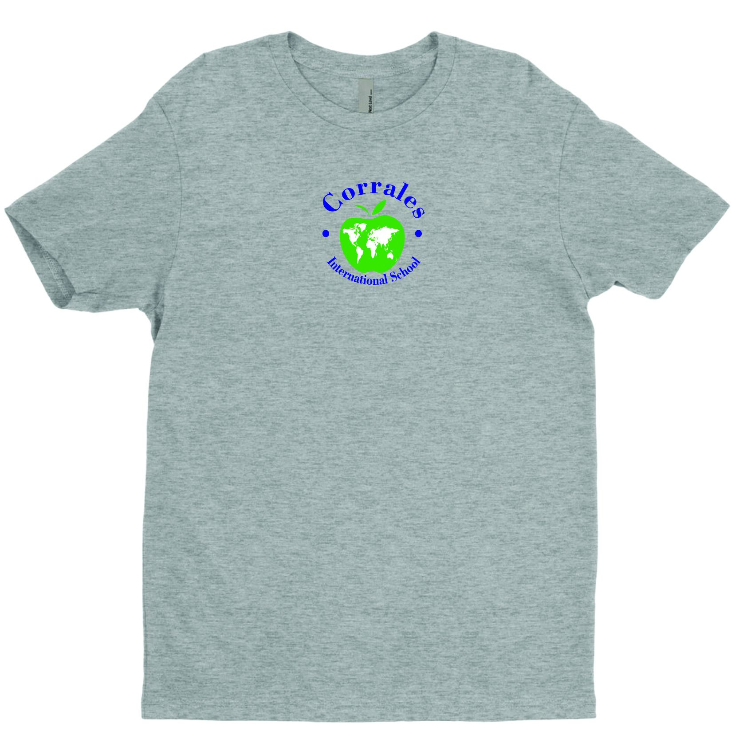
Available in. Royal & Gray. Available in
Royal, Green. Sizes XS-XL. Royal & Gray
White.
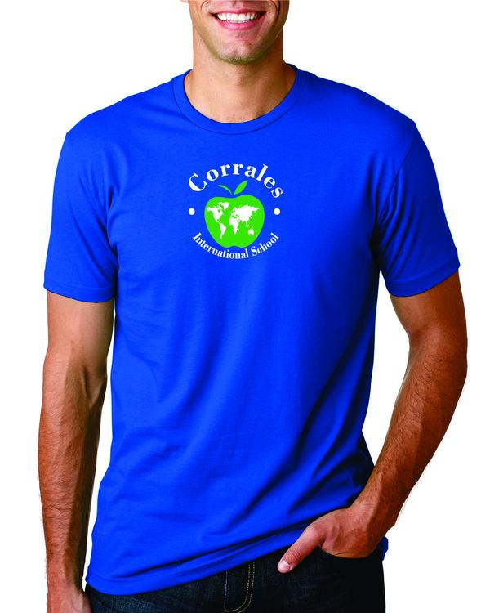
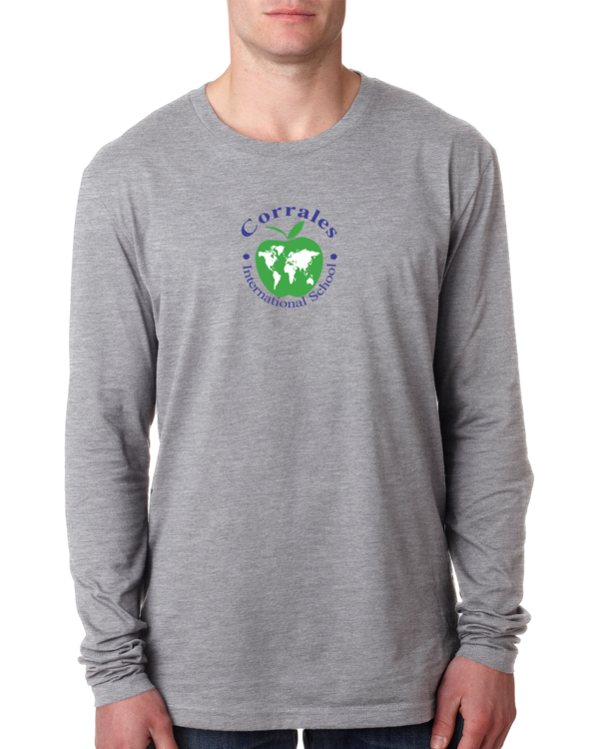

Adult Long Slv
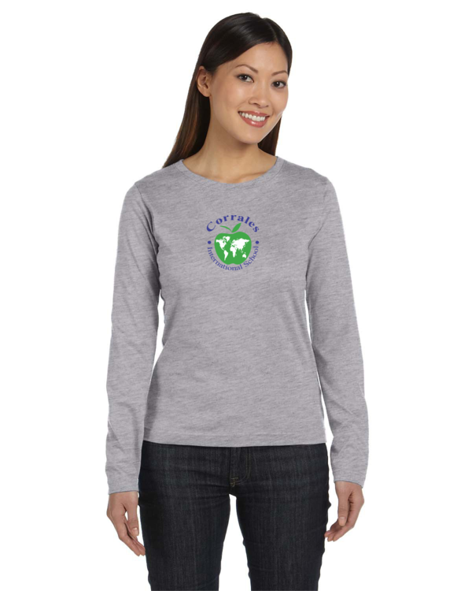
Spirit Shirt
$13.00
Available in. Ladies Long Slv
Royal & Gray. Spirit Shirt.
Sizes Sm-XL. $13.00
Available In
Royal & Gray

Please turn page over for more MYP Apparel.
Youth sizes are also available how ever PE sweat pants & shorts are for MYP only.
To order please go to www.firedawgshirts.com please double check sizes and refer to size charts. As All Sales are Final! No refunds. No Exchanges. No Credit will be given.
No excuses. Like us on Face book for special offers and reminders Thank You.
If you have any questions please call 505-750-1672 or Tara 505-681-8694

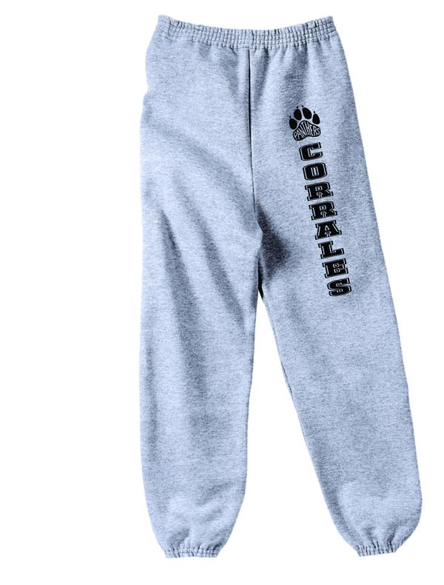
MYP continued
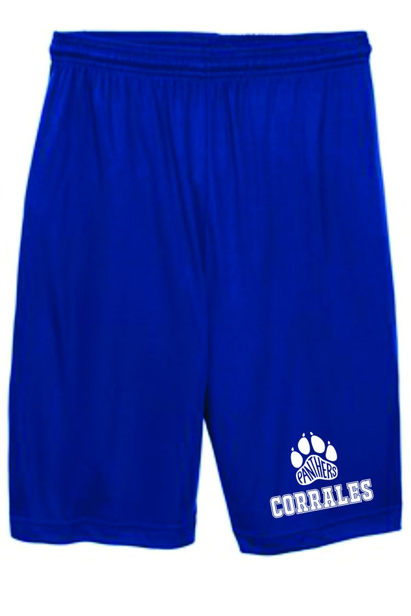

MYP Pe sweat Pants MYP P.E Shorts
$13.50. $8.50
Sizes Sizes
SM-XL $13.50. SM-XL $8.50
Sizes 2XL $9.50
2XL-3XL $15.00.
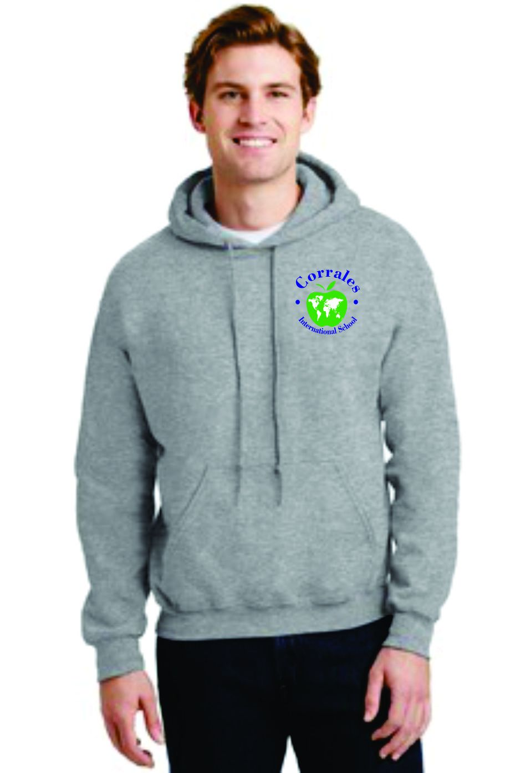
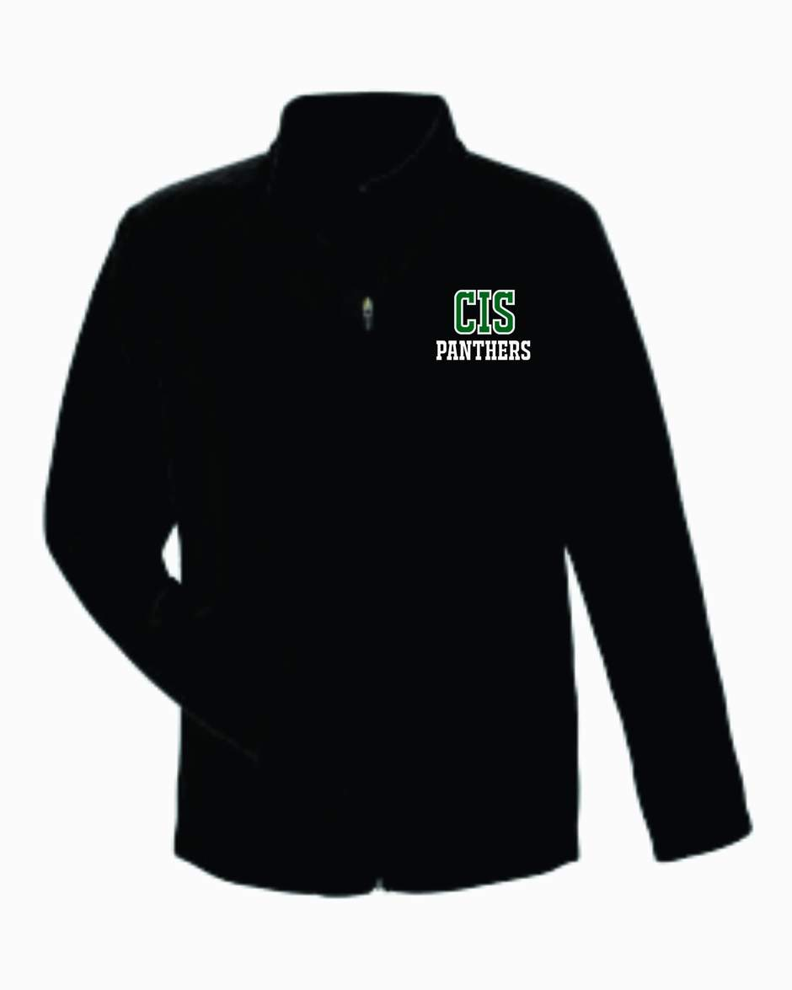

Pullover Hoodie Campus Fleece
Or Zip-up $30.00 sizes
XSm-XL Hoodie. $32.00 size 2Xl-3XL
$22.00 sizes Sm-XL Available in Ladies
$24.00 sizes 2XL-3XL. Youth & Adult
Available in Royal A name can
Or Gray. be added for $3.00
A name can be added for $3.00 more
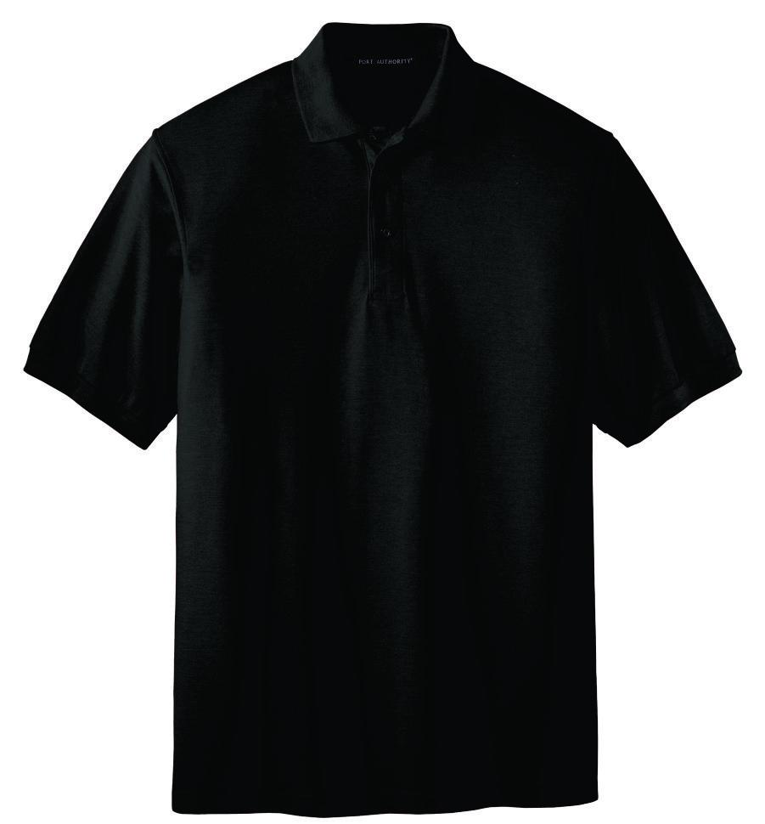
more.
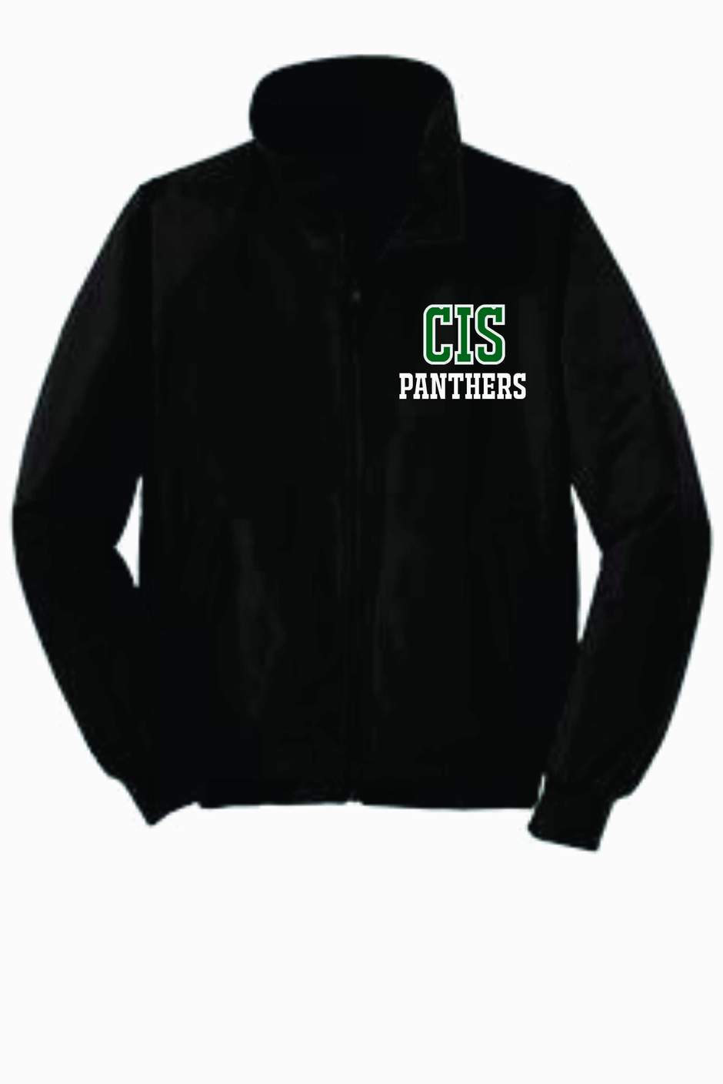

Charger Jacket. BLACK Polo
Sizes XSm -XL $37.00. Is exclusively for
Sizes 2XL-3XL $39.00. Traditional Track
A name can be added for $3.00. 11 & 12 Grade
more. only!
Available in black only

To order please go to www.firedawgshirts.com please double check sizes and refer to size charts. As All Sales are Final! No refunds. No Exchanges. No Credit will be given.
No excuses. Tax will be added at time of order being placed. Like us on Face book for special offers and reminders Thank You.
If you have any questions please call 505-750-1672 or Tara 505-681-8694

