CIs - pyp NEWS
A NUT-FREE SCHOOL

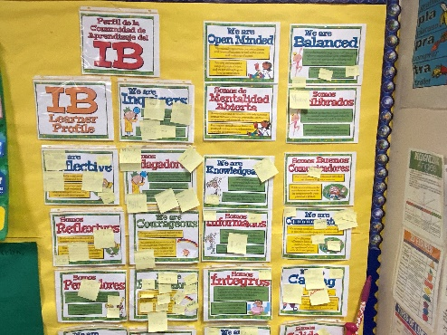  PYP reflects on the IB learner profiles  Important Notes to our PYP community  Important notes for our community  With this mini-newspaper, we inform you about our school. Please take a minute and read it.  Dear CIS Community,  Here are some important reminders:  The school opens at 7:30 AM and closes at 2:30 PM except on Wednesdays when it closes at 1:30 P.M. If your student has tutoring; this schedule may change (contact the teacher to know the details). However, your student MUST be picked up on time or waited at the end of the tutorial in our parking lot. If you are unable to be on time, please contact After Care at 505-242-3353.  There is Chess CLUB on Wednesdays, contact Coach Stephen if you are unable to pick up your child(ren) on time. Coach Stephen's work is voluntary, and he needs to know and plan.  Remember, if your student(s) have a fever, please keep them home and let the front desk know or email our registrar Mrs. Dawn Jackson at Jacksond@corralesis.org  On October 6 and 7 there is NO CLASS. We are on a fall break.  We are looking for a few more substitute teachers; if you are interested or know someone, please call Patti Brainard at 344-9733 ext. 127.  If you have any questions, please do not hesitate to contact the Head of School at Tolleym@corralesis.org or the Vice-Principal and Bilingual Director at Pereaa@corralesis.org | 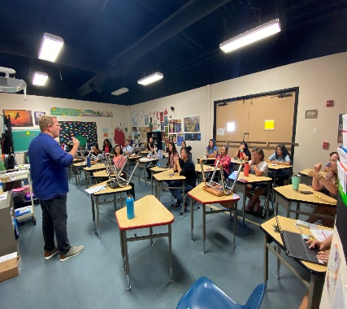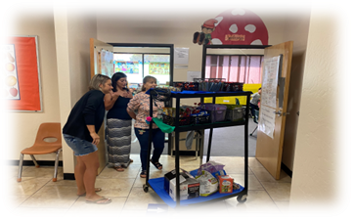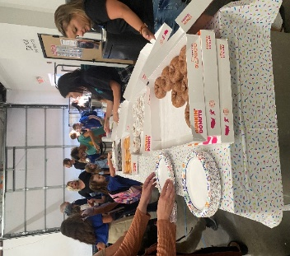  Leadership, PTA, and Parents’ participation are essential in CIS!  CIS IB School
 | 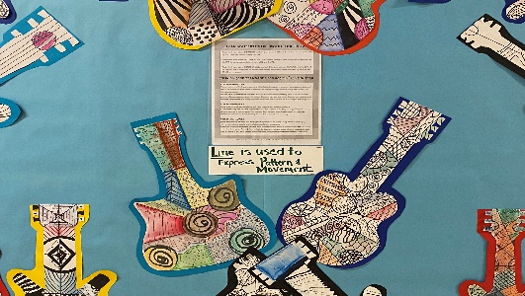  Specials are academics in CIS  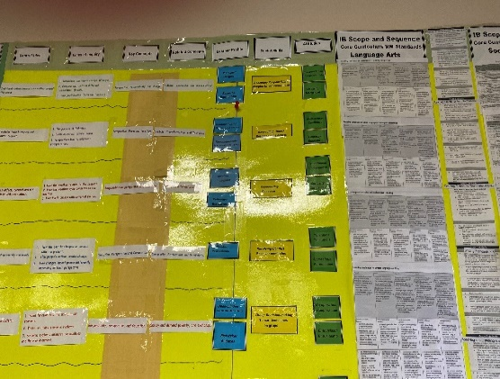  Year Plan 2022-2023!  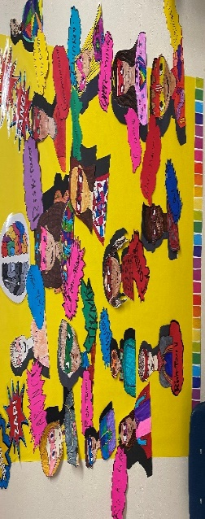  PYP-IB and LP! | 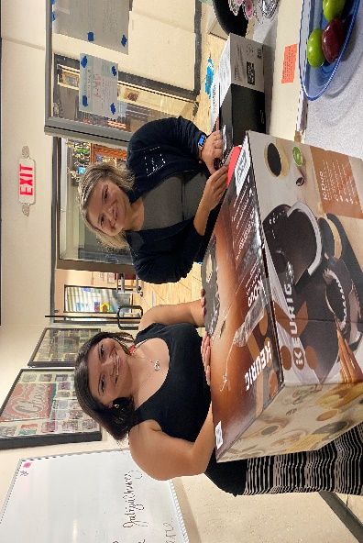  We need parents to participate in our Parents Association. This is teamwork. Please connect to: evannaromero@gmail.com  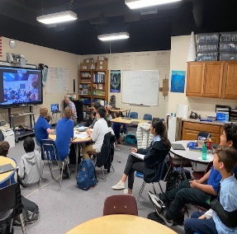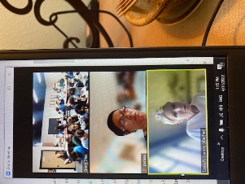  Our community participates  Science fair (in the classrooms) and EXPLORA (MPR) on October 25th from 4:00 a 6:30 P.M. at CIS

