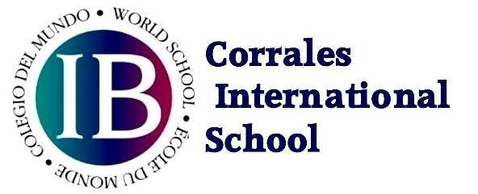
Dear Parents,
Welcome to the 2023-2024 school year at Corrales International School. This school year we have a full program of activities!
Corrales International School Middle Year Program (MYP) Curriculum Framework World Schools share a common philosophy—a commitment to improving the teaching and learning of a diverse and inclusive community of students by delivering challenging, high-quality programme of international education that share a powerful vision.
The IB Middle Years Programme consists of eight subject groups:
- Language Acquisition
- Language and Literature
- Individuals and Societies
- Sciences
- Mathematics
- Arts
- Physical and Health Education
- Design
Every subject is aligned with IB Student Profiles, Attributes, and Approaches To Learning, as well as the NM Common Core State Standards (CCSS).
Each teacher will communicate frequently to explain in detail the units and other activities during the school year.
Please visit our webpage at corralesis.org for schedules and activities.
We welcome Mr. Anthony Valdez returning to CIS-MYP.
- Don’t forget that school starts at 8:00 A.M. on Monday, July 31st!
Feel free to contact me if you have any questions at pereaa@corralesis.org
Sincerely and respectfully,
Dr. Ana Perea

