April. CIS
Breakfast 2025

Nama Catering  Nama catering makes healthy, homemade, delicious meals. We use whole grain and whole wheat in bread and pastas whenever possible. Nama strives to buy local and organic ingredients when available and supports our local farmers. All lunches will be served with low fat milk.  *Menu items are subject to substitution without notice | 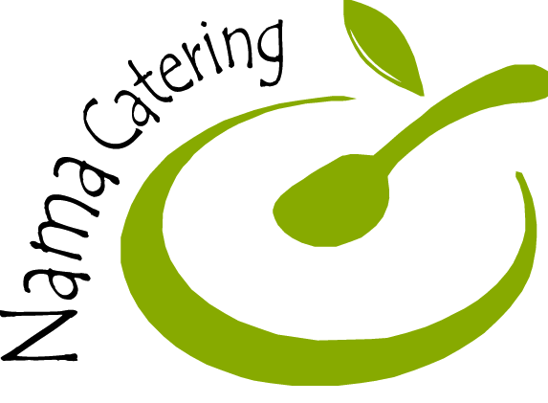

Monday | Tuesday | Wednesday | Thursday | Friday
 | 1  Double Muffins | 2  Breakfast Bar and Fruit | 3  Assorted Cold Cereal with fruit | 4  Cinnamon Muffin with String Cheese
7  Granola Bar and gogurt | 8  Double Muffins | 9  Breakfast Bar and Fruit | 10  Assorted Cold Cereal with fruit | 11  Blueberry Muffin with String Cheese
14  Granola Bar and gogurt | 15  Double Muffins | 16  Breakfast Bar and Fruit | 17  Assorted Cold Cereal with fruit | 18  NO SCHOOL
21  Granola Bar and gogurt | 22  Double Muffins | 23  Breakfast Bar and Fruit | 24  Assorted Cold Cereal with fruit | 25  Banana Chocolate Chip Muffin with String Cheese
28  Granola Bar and gogurt | 29  Double Muffins | 30  Breakfast Bar and Fruit | 1  Assorted Cold Cereal with fruit | 2  Apple Cinnamon Muffin with String Cheese

