Corrales International School
Governing Council Regular Meeting
5500 Wilshire Ave. NE
Albuquerque, NM 87113
September 9th, 2025 – 5:00 p.m.
DRAFT meeting minutes: not official minutes and are subject to approval by the public body.

- Call to Order 5:01 pm.

- Roll Call
Lily P., John R., Angela G., Mark T (Head of School), Rebecca R (Business Manager).
Absent: n/a

- Adoption of agenda September 9th, 2025
Motion Lily P
2nd Angela G
Discussion: n/a
No Opposition
Passed

- Adoption of Meeting Minutes for August 12th, 2025
Motion Lily P
2nd Angela G
Discussion: misspelling of acronym GASB
No Opposition
Motion Passed

- This is an opportunity for members of the public to address the Governing Council ("GC") for up to 3 minutes with comments or issues, whether or not they are posted on the agenda. The Chair may reduce the time for each participant to speak to ensure adequate time to conduct GC business. The GC, by law, cannot take action or have any discussion or deliberation on any presentation made to it concerning an item not listed on the agenda. Any item presented may be noticed on a future agenda for deliberation or action. Those wishing to participate must sign in on the Public Comment sheet or post their Name, phone number, email address, and topic in the chat for those online.
Present: n/a

- Finance Update
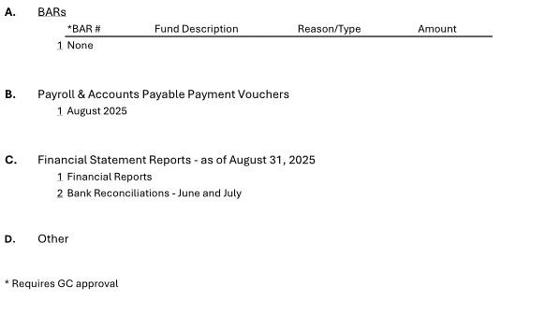
- BARS - None
No Motion

- Motion to approve Payroll & Accounts Payable Payment Vouchers August 2025
Motion Lily P
2nd Angela G
Discussion: Went over checks in finance committee meeting. Questions raised were answered. 1st payroll check is a 0-dollar direct deposit to make sure it is working. 1st paycheck is a paper check. Questions on landscaping, property owner took care of. We covered a portion of the cost. The CR refrigeration was for filters and other hardware for the swamp coolers. What is ABCWUA? Albq water Authority. CPI is crisis intervention.
No Opposition
Motion Passed

- Financial Statements Reports as of August 31st, 2025
Discussion: 5 funds that have been operating. Operational fund is our main fund. Increase of $30,000. IDEA – haven’t received revenue yet as it is a reimbursement fund. Lease assistance is handled in the same way as IDEA. Expenditures were coded. An average student counts. Some funding received from SB. Actual expenditure reviewed. We have about 7 months of expenditures saved. Estimated capital resources for building purchase reviewed. New salaries also began. Building: estimate: 3.9 mil by end of June 2026. Monthly case balance, all funds, reviewed.
Bank Reconciliation: reviewed.

- Other: n/a

7. GC Business

- Addition of Governance Council Member
  - We need to add a member to the board. We are required to have at least 5. It needs to be a community member, not a parent or anyone connected to the school.

B. Executive Session – Personnel and Capital matters

Consideration for the Approval to Adjourn to Executive Session Pursuant to Section 10-15-1(H)(8) for the Purpose of the discussion of limited personnel matters and for the Purpose of the discussion of the purchase, acquisition or disposal of real property or water rights by the public body. (Discussion/Action)

Language Into Closed Session:

Motion to move that the Governance Council of Corrales International School convene in closed session to discuss limited personal matters related to staffing and discussion of the purchase, acquisition or disposal of real property as authorized by section 10-15-1 of the New Mexico Open Meetings Act.

Motion Angela G
2nd Lily P
No Discussion
No opposition
Motion Passed

Roll Call: Bruce H, Lily P, Angela G, John R

Language Out of Closed Session:

Motion to move that the Governance Council reconvenes in Open Session and that all matters discussed in the closed session were limited to only those specified in the motion for closure.

Motion Lily P
2nd Angela G
No Discussion
No opposition
Motion Passed

Roll Call: Bruce H, Lily P, Angela G, John R

8. Head of School
- Start of School update.
We pay higher than the district. A discrepancy was found in pay schedule compared to APS. APS put out their pay schedule in July, after salaries were determined. Once this discrepancy was found, additional compensation was provided to teachers.

- Additional Compensation
Additional compensation will be considered for a couple of staff members that have stepped up to help us while we are looking for new individuals to fill those positions. Question about how many months we should have in reserve? There does not appear to be a required amount.

9. Other Business/GC Member Comment: This is an opportunity for any GC member to make a comment.

- Adjournment 6:14 pm
Motion John R
2nd Lily P
Discussion: n/a
No opposition
Motion Passed

The next regular meeting of the Governing Council will be on October 14^{h}, at 5:00pm and will take place at 5500 Wilshire Ave. NE, Albuquerque, NM 87113 or Zoom remote as needed.

“If you are an individual with a disability who is in need of a reader, amplifier, qualified sign language interpreter, or any other form of auxiliary aid or service to attend or participate in the hearing or meeting, please contact the CIS Head of School at 505-344-9733 at least one week prior to the meeting or as soon as possible. Public documents, including the agenda and minutes, can be provided in various accessible formats. Please contact the CIS Head of School at 505-344-9733 if a summary or other type of accessible format is needed.”

Remote attendance on Zoom:
Join Zoom Meeting

https://us02web.zoom.us/j/89522502931?pwd=azYK52VnHfODb0lqp3IEnoHDFbiZYE.1

