Corrales International School Governing Council Regular Meeting 5500 Wilshire Ave. NE Albuquerque, NM 87113
February 10th, 2026–5:00 p.m.

DRAFT meeting minutes: not official minutes and are subject to approval by the public body.

- Call to Order at 5:04 pm.

- Roll Call
Bruce H, Angela G, Lily P, Mark T (Head of School), Rebecca R (Business Manager).
Absent: John R

- Adoption of Agenda
February 10th, 2026
Motion Lily P
2nd Angela G
Discussion: n/a No Opposition Passed

- Adoption of Meeting Minutes for January 13, 2026, with removal of second noted year in heading, adjournment at 5:33 pm 5:33pm
Motion Lily P
2nd Angela G
Discussion: Changes noted
No Opposition Motion Passed

- This is an opportunity for members of the public to address the Governing Council ("GC") for up to 3 minutes with comments or issues, whether or not they are posted on the agenda. The Chair may reduce the time for each participant to speak to ensure adequate time to conduct GC business. The GC, by law, cannot take action or have any discussion or deliberation on any presentation made to it concerning an item not listed on the agenda. Any item presented may be noticed on a future agenda for deliberation or action. Those wishing to participate must sign in on the Public Comment sheet or post their Name, phone number, email address, and topic in the chat for those online.
Present: n/a

- Finance Update
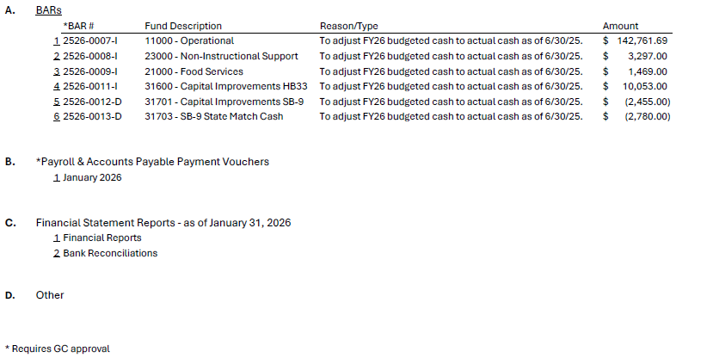

  - Motion to approve BARS 2526-0007-l (operational FY26 adjustment $142,761.69); 2526-0008-l (Non-Instructional Support adjustment $3,297.00); 2526-0009-l (Food Services adjustment $1,469.00); 2526-0011-l (Capital Improvement HB33 adjustment $10,053.00); 2526-0012-D (Capital Improvements SB9 adjustment ($2,455.00)). 2526-0013-D (State Match Cash adjustment ($2,780.00)).
Motion Lily P
2nd Bruce H
Discussion: Increase BAR; 2nd BAR, student activity fund increase; 3rd BAR, increased;
HB33 increased; SB9 decrease; BAR 6th decrease.
No Opposition
Motion Passed

  - Motion to approve Payroll & Accounts Payable Payment Vouchers January 2026
Motion Lily P
2nd Angela G
Discussion: Reviewed checks and ledger balance. Audit is complete, charge reviewed.
No Opposition
Motion Passed

  - Financial Statements Reports as of January 31st, 2026, Bank Reconciliations Discussion: Expenditures Analytical Review. Reviewed Revenue/Expenditures by fund. Compensation & Benefits 66%. Reviewed actual spenditures. 3.8 mil for building purchase. Reviewed Monthly cash balance funds, bank reconciliations and bank statement.

  - Other: n/a

- GC Business

Consideration for the Approval to Adjourn to Executive Session Pursuant to Section 10-15-1(H)(8) for the Purpose of the discussion of limited personnel matters and for the purpose of the discussion of the purchase, acquisition or disposal of real property or water rights by the public body. (Discussion/Action)
Language Into Closed Session:
Motion to move that the Governance Council of Corrales International School convene in closed session to discuss limited personal matters related to staffing and discussion of the purchase, acquisition or disposal of real property as authorized by section 10-15-1 of the New Mexico Open Meetings Act.
Motion Lily P
2nd Angela G
Discussion: n/a No Opposition Motion Passed
Roll Call: Bruce H, Angela G, Lily P Language Out of Closed Session:
Motion to move that the Governance Council reconvenes in Open Session and that all matters discussed in the closed session were limited to only those specified in the motion for closure.
Motion Lily P
2nd Angela G
Discussion: n/a No Opposition Motion Passed
Roll Call: Bruce H, Angela G, Lily P

- Head of School
- Charter School/NMPED/APS updates.
  - Legislation: math, language arts, raises for teachers. NMPED are working on accrediting schools.
  - APS: New leadership; Corrective action
- School Updates
  - Released report cards. Increased in points. I-Ready assessments have shown improvement overall. We have implemented various resources based on data. We continue to receive applications for lottery. We are working with Vortex. GC would like to extend their appreciation to the staff for the improvements that are being made and recognize their accomplishments.

- Other Business/ GC Member Comment: This is an opportunity for any GC member to make a comment.

- Adjournment 5:48 pm Motion Lily P
2nd Angela G
Discussion: n/a No opposition Motion Passed
The next regular meeting of the Governing Council will be on March 10th at 5:00pm and will take place at 5500 Wilshire Ave. NE, Albuquerque, NM 87113 or Zoom remote as needed.
Remote attendance on Zoom:
Join Zoom Meeting

https://us02web.zoom.us/j/89522502931?pwd=azYK52VnHfODb0lqp3IEnoHDFbiZYE.1
“If you are an individual with a disability who is in need of a reader, amplifier, qualified sign language interpreter, or any other form of auxiliary aid or service to attend or participate in the hearing or meeting, please contact the CIS Head of School at 505-344-9733 at least one week prior to the meeting or as soon as possible. Public documents, including the agenda and minutes, can be provided in various accessible formats. Please contact the CIS Head of School at 505-344-9733 if a summary or other type of accessible format is needed.”

